Assessment Task 2: Design a Database

|  |  |
| --- | --- |
| Course code and title | **ICT50220 Diploma of Information Technology** |
| Unit code and  title | **ICTWEB517 Create web-based programs** |
| Due date | 9/06/2024 – Please refer to Moodle |
| Resources  required | • ICTWEB517 Moodle Site  • Access to computer and internet  • Learner resource |
| Decision making rules | To achieve an overall satisfactory result for this assessment task:   * Learners must achieve a satisfactory result for each item in the **Assessment Checklist** |
| Learner  instructions | This task involves completing a design brief, sitemap and storyboard for a website. Refer to the Project Scenario below for more details.  For this task you will:   * Complete it individually. * Write answers to all questions by completing the design brief template, providing a site map and a storyboard. * Complete it within 3 hours class time and submit it by the due date. * Have time to read and review the assessment task in class. * Submit your answers electronically via Moodle. * Answer electronically and save the document as Assessment Task2StudentID.docx.   You must agree with the assessment submission terms and conditions by clicking on the ‘I confirm’ radio button in Melbourne Polytechnic Moodle prior to the submission.  If you have any questions about the task or concerns about your ability to complete the task, please discuss this with your Assessor. |

# Project Scenario

Using the website that you created for ICTWEB513 last term, then insert the dynamic contents into the website. You may have a different topic other than the Melbourne Public Library scenario, but we use the Melbourne Public Library as an example, you need to complete the assessment tasks accordantly.

In this task, you must read the below email from the Project Manager and complete the design document for this task.

|  |
| --- |
| *Dear Web Developer*  *This is great. We went live this morning and it’s working really well!*  *We’ve now decided that we would like to expand the website. We would like to allow users (external) to register a membership, and then log into the system when ever they need to, the user can browse through a range of pre-determined consumer products (books) and view or search a product (book) after logged in.*  *We would like all users (external) to be able to view the basic information and search a product on the website, but only the admins (internal staff) should be permitted to view the tracking information of user (external) searches within the website.*  *The admin login name is “*Library*”, and the password is “admin123”*  *I note the 5-day turnaround and will work within your organisation’s policies and procedures to get this up and running.*  *Kind Regards*  *Project Manager* |

# Part 1: Identify the requirements for the project

Please list the requirements for the project here.

all users (external) to be able to view the basic information and search a product on the website

user can browse through a range of pre-determined consumer products (books)

only the admins (internal staff) should be permitted to view the tracking information of user (external) searches within the website

allow users (external) to register a membership, and then log into the system when ever they need to

view or search a product (book) after logged in

# Part 2: Design database tables

Please read the requirements for each table, and fill the tables under each questions

1. An **accounts** table to store the details of users who have registered in the website, the table should have at least **4 fields**. The user’s email address can be used as the login name, the userId is an auto increment number, which is a Primary Key for this table.

|  |  |  |
| --- | --- | --- |
| Field Name | Data Type | Required |
| userId | int(10) | primary key |
| user_email | varchar(24) | not null |
| userPassword | varchar(25) | not null |
| is_admin | varchar(8) | not null |

* The **userId** field should be the Primary Key for this table.

1. A **products** table to store the details of products that are available for review, the table should have at least 4 fields including a field to store the name of the image for each product(book).

|  |  |  |
| --- | --- | --- |
| Field Name | Data Type | Required |
| id | int | primary key |
| book_title | varchar(51) | not null |
| bookPrice | double | not null |
| image | varchar(65) | not null |

* The **id** field should be the Primary Key for this table.

1. A **tracking** table to store the search details that the viewer entered into the search box. The table should have at least 2 fields, one of them is the trackingId which is an auto increment number as a Primary Key.

|  |  |  |
| --- | --- | --- |
| Field Name | Data Type | Required |
| trackingId | int(10) | primary key |
| tracking_data | varchar(85) | not null |

* The **trackingId** field should be the Primary Key for this table.

## Part 3: Confirm with Client

Draft an email to the Project Manager with your database design document.

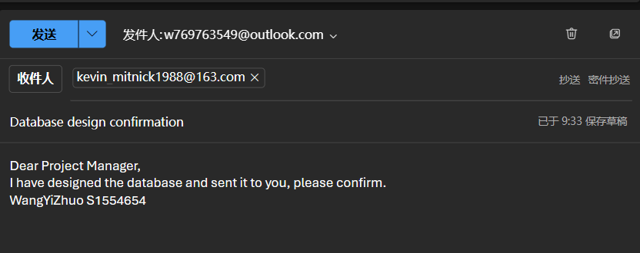

#### Instructions for submission

* Upload the design document into Melbourne Polytechnic LMS site (<https://online.melbournepolytechnic.edu.au>).

# Assessment Checklist: Task 2 - Design a database

|  |  |  |  |  |  |  |
| --- | --- | --- | --- | --- | --- | --- |
| **Learner name** | | WangYiZhuo | **Student ID** | | S1554654 | |
| **Assessor name** | | Mr. WU | **Date** | | 9/06/2024 | |
| Assessment checklist 1  assessor to complete the following | | | | | | |
|  | | | | | | |
| **The LEARNER has demonstrated the following in Part 1:** | | | | **SATISFACTORY** | | **NOT SATISFACTORY** |
|  | Completed database design:   * Identify the requirements * Database * accounts table * products table * tracking table * communication with the client(s) | | |  | |  |
| **Feedback -** Assessor must include feedback about the observed performance | | | | | | |
| *the student has completed all parts of the task.* | | | | | | |
| **The LEARNER has demonstrated the following in Part 2:** | | | | **SATISFACTORY** | | **NOT SATISFACTORY** |
|  | Created a database as per specifications | | |  | |  |
| **Feedback -** Assessor must include feedback about the observed performance | | | | | | |
| *the student has properly completed the database.* | | | | | | |
| **The LEARNER has successfully demonstrated the following in Part 3:** | | | | **SATISFACTORY** | | **NOT SATISFACTORY** |
|  | Confirmed with the client | | |  | |  |
| **Feedback -** Assessor must include feedback | | | | | | |
| *the student has sent the email to client.* | | | | | | |

# Assessment Task Summary: Task 2 - Design a database

| **Trainer/Assessor to complete the following:**  **Needs to be customised for the tasks**  **THE LEARNER:** | | | Yes | No |
| --- | --- | --- | --- | --- |
| 1. | Satisfactorily completed all items in Assessment Checklist | |  |  |
| **FEEDBACK** | | | | |
|  | | | | |
| **OVERALL TASK RESULT** | | | | |
| Satisfactory  Not Satisfactory (resubmission required) – Due date: ____________________________ | | | | |
| **DATE ASSESSMENT RETURNED** | |  | | |
| **TRAINER/ASSESSOR NAME** | |  | | |
| **TRAINER/ASSESSOR SIGNATURE** | | X | | |

| **LEARNER DECLARATION: Please read, tick and sign below** | | | |
| --- | --- | --- | --- |
| I, __WangYiZhuo_______________have been advised of the outcome of this assessment task.  PRINT NAME | | | |
| **LEARNER Signature** | WangYiZhuo | **Date** |  |